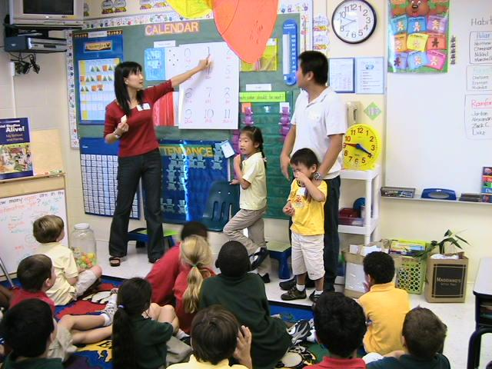
Family Guidelines for School and Classroom Interaction and Volunteering
Parents are encouraged to be an integral part of our school program and community. We want parents to be involved with us in the learning that takes place with their children. One of the best ways to increase student achievement is by parental involvement. Volunteering is a great way to get to know the school and other parents. You can volunteer to help in a number of ways, including:
- Serving as a class parent
Chaperoning fieldtrips
- Sharing special knowledge with the class about your culture, career or expertise
- Serve on the School Advisory Committee
- Providing food or time for events (picnic, field day, etc.)
- Serving on special committees
- Speak with the Principal to assist with school-wide projects
- Join MacDaddies
- Speak with the Principal or PTA President if you would like to become involved with their wide range of
school activities.

Classroom Volunteers
Teachers always need an extra pair of eyes and hands in the classroom. Volunteer for an hour or two a week (or whatever fits into your schedule) helping teachers with tasks such as reading with or to individual students, working with a child or a group in the classroom, etc. If being here in person does not fit your schedule, you can help out by volunteering to do cutting, collating, running copies, etc.

- An adult arranges a visit in advance with the school (e.g. teachers, homeroom parent, administration) We ask that the adult attending adhere to the daily routines and procedures of MacFarlane Park including respecting the privacy and workload of staff, who are not available for social purposes during the school day.
- The adult attending may assist with the child and his/her friends during independent work time.
- The adult attending may not address teachers during instructional time or during class transitions. They are asked to make an appointment to meet with teachers at a time convenient to both parties.

Homeroom Parents
Certain school events cannot happen without active room parents. Please consider being a room parent for your child’s class. Homeroom parents are the liaison between teacher, PTA and class families. They assist in family involvement and facilitate home-school connection. They work with other to support, enrich, and create a rewarding educational experience for our children. If you are interested, please let your child’s teacher know.

How Do I Apply To Volunteer?
To maximize student and employee safety, it is school board policy to screen all applicants via a criminal and sexual predator/offender background check. Please click on link below to access the Volunteer application and guidelines.

**Volunteer Application and Guidelines Link
https://community.sdhc.k12.fl.us/wps/portal/community/sdhc.home/sdhc.volunteer/sdhc.applyvolunteer/#/

